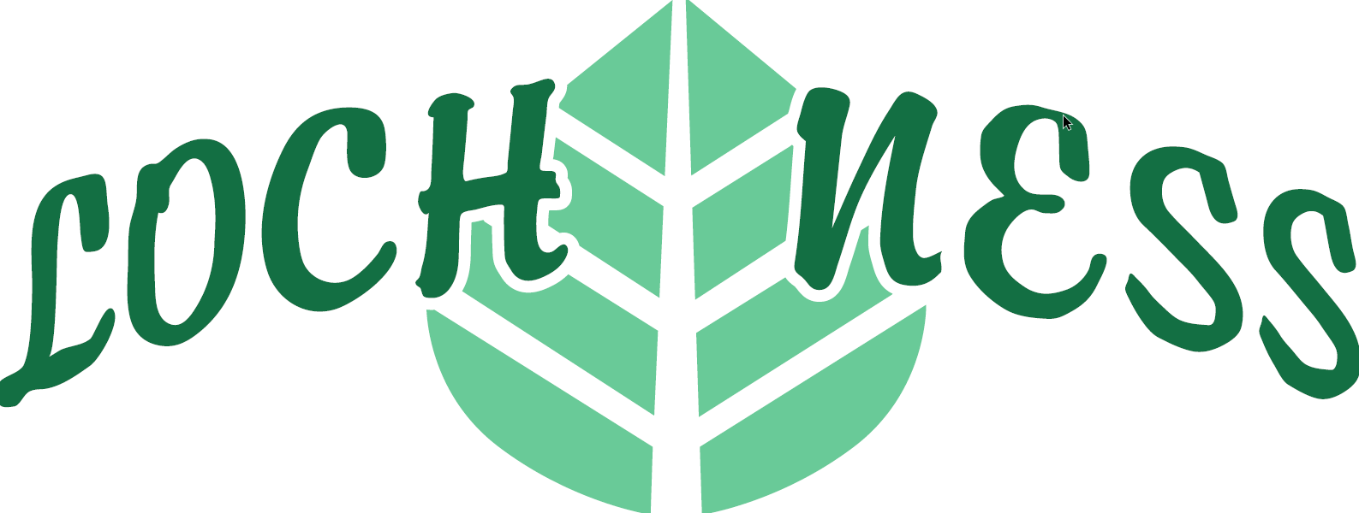
LOCH NESS HOMEOWNERS ASSOCIATION, INC.
8004 NW 154th street – P.O. Box 411, Miami Lakes, Fl 33016
WWW.LOCHNESSDRIVEHOA.COM
(305) 235-3835 Ext 101
TO: All Loch Ness Homeowners
Our next Board and General Elections Meeting will take place on Thursday February 5th ,2026 at 6:30 P.M. at Mary Collins Community Center located at 15150 N.W. 82nd Ave, Miami Lakes, FL 33016.
PURPOSE OF MEETING: Hold General Elections to elect the President, Vice President, Secretary, Treasurer, and all other Officers and Directors who will serve for 1 year (February 2026 - February 2027). Also discuss such business as may properly come before the meeting, or any adjournment thereof. Each lot of the subdivision shall have l (one) vote. The voter must be the registered owner of the property, as it appears on the deed and the tax rolls, and must be up to date in the annual dues and any special assessments. There must be at least 10 homeowners present at the meeting, including 4 directors, in order to have a quorum.
THE LIMITED/PROXY ABSENTEE BALLOT form enclosed is provided in the event that you are unable to appear in person to vote on Election Day. This form can be used as your Ballot if you vote in person or as an Absentee Ballot if you use it as a PROXY in order to have someone else vote on your behalf.
A NOTICE OF INTENT to be a candidate and Information Form will be provided upon request to any homeowner seeking a position in our Board of Directors for 2026. These forms must be completed, signed and mailed to Loch Ness Homeowners Association 8004 NW 154 Street, Miami Lakes, FL 33016 by no later than December 15th, 2025.
We look forward to seeing you there
Sincerely,
Manny Ribadeo
President

